1. Agenda:
   1. Create Kafka Listener Container.
2. Kafka Listener container will be responsible to receive the msgs from Kafka Topic and invoking the handler method or listener method in java code.
3. 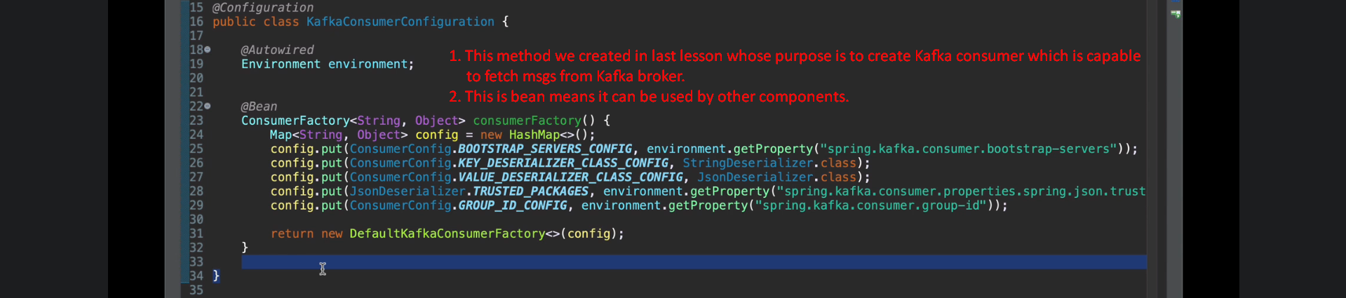
4. 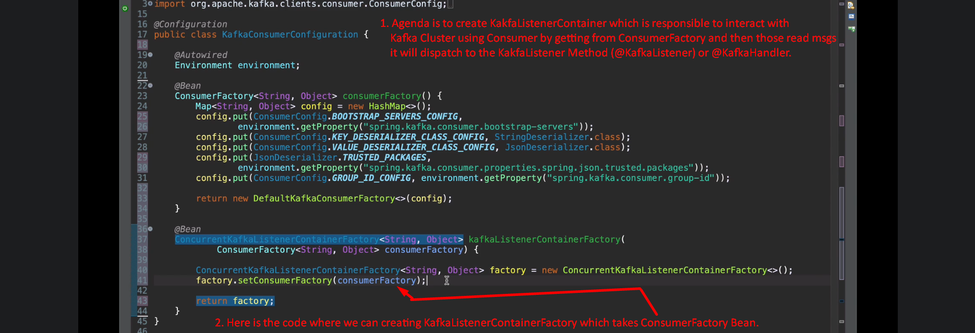  
   Actually KafkaListenerContainerFactory manages all the configurations and beans such as
   1. Configuration: How many concurrent threads are required.
   2. Beans: ConsumerFactory Bean.